Grade 7 Accelerated · Unit 3 · Assessment  Exponents and Scientific Notation  41 points | Name______________________  Date______________________  Period____________________

Show your work. Circle your final answer.
This assessment runs over two class periods. Stop when the period ends; you will continue from where you stopped.
If an earlier part is wrong, a later part still earns its point when the right operation is applied to your own earlier answer — but only if that work is on the page.
1. Laws of Exponents 9 points
1. Write each expression as a single power.
a. 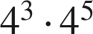 1 pt

b. 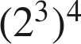 1 pt

c. 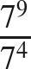 1 pt

d.  (give its value) 1 pt

2. Find the value of each expression.
a. 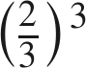 1 pt

b. 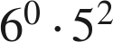 1 pt

c. 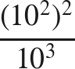 1 pt

3. Which expression is equivalent to  ? 1 pt
○ A. 
○ B. 
○ C. 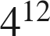
○ D. 

4. Find the value of that makes the statement true: 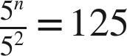 1 pt

2. Integer Exponents 11 points
5. Rewrite each expression with positive exponents. Do not evaluate.
a. 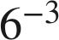 1 pt

b. 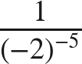 1 pt

c. 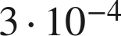 1 pt

6. Find the value of each expression.
a. 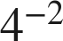 1 pt

b. 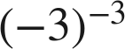 1 pt

c. 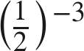 1 pt

d. 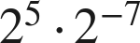 1 pt

7. Which is the value of 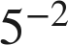 ? 1 pt
○ A. 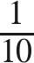
○ B. 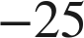
○ C. 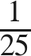
○ D. 

8. Select ALL of the expressions whose value is 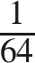. 1 pt
□ A. 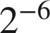
□ B. 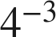
□ C. 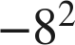
□ D. 
□ E. 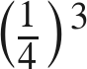

9. Marco says the value of 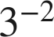 is 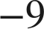. Explain why he is wrong, and give the correct value. 1 pt

10. Which is greater, 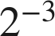 or ? Show how you know. 1 pt

3. Variable Bases 9 points
11. Write each expression as a single monomial.
a. 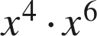 1 pt

b. 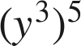 1 pt

c. 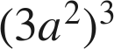 1 pt

d. 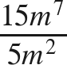 1 pt

12. Rewrite each expression using only positive exponents.
a. 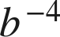 1 pt

b. 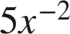 1 pt

c. 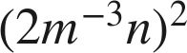 1 pt

13. Which expression is equivalent to 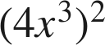 ? 1 pt
○ A. 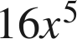
○ B. 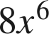
○ C. 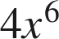
○ D. 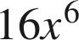

14. How are  and 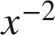 related? Explain, and give the value of each when 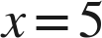. 1 pt

4. Scientific Notation 12 points
15. Write each number in scientific notation.
a. 8,300,000 1 pt

b. 0.00047 1 pt

c. 60,500,000,000 1 pt

d. 0.0000000092 1 pt

16. Write each number in standard form.
a. 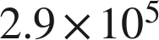 1 pt

b. 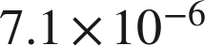 1 pt

17. Which is 0.0036 written in scientific notation? 1 pt
○ A. 
○ B. 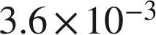
○ C. 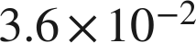
○ D. 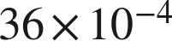

18. Answer each question.
a. How many times larger is 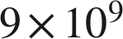 than  ? 1 pt

b. How many times larger is 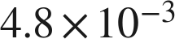 than 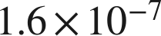 ? 1 pt

19. Which is greater, 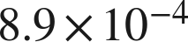 or 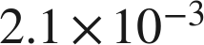 ? Explain how you know. 1 pt

20. A computer displays a number as 5.6E8. Write the number in standard form. 1 pt

21. Between which two consecutive powers of 10 does 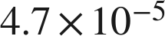 lie? 1 pt

